Please ensure make sure to check back every amendment list if you have done it.

1. I merged the data in one dataframe before deleting them:  
     
   that had all the data, so instead of leaving the 4 large datasets in my computer’s memory that was almost full because of your large datasets, I removed them because they’re no longer needed, if want to you can delete this cell (it has no purpose but to reduce the used memory):

del data1,data2,data3,data4

1. Can I know why you only pick with the range of 1 to 15 ? Especially that range was usually 0, isn’t it better to choose with those that has value?

# Genrating needed lags:

for i in range(1,15):

    data["lag_{}".format(i)] = data['Solar Avg'].shift(i)

data.dropna(*axis*=0,*inplace*=True)

data.head()

they are 0s in the first 5 rows, but that does not mean they will keep to be 0s till the end of the data set, they change.

1. All the CSV File, I want it hourly not every second (as the title stated as hourly). And also, can you remove all the lag columns?

OK

1. I believe Hybrid and Ensemble Model is two different things, the hypered model you did was an ensemble model. However, the initial requirement were

*“(iii) Hybrid ELM-LSTM Or any Hybrid one [Or any hybrid method that has not been used to predict solar irradiance before that give a BETTER accuracy than (i) and (ii) method][^ Please let me know first, i want to make sure the hybrid method give better results compare to other standalone algorithm]”*

*Well I searched on how to preform a hybrid model form ELM and LSTM and the results were just like what I built, so if you have anything else in mind please share.*

1. The hyperparameter tuning , since the data is relatively large, it’s better to use Bayesian Optimization Technique or Gradient Based Optimized Technique rather than GridSearchCV as my current data set is not small.

No need for that after I group the data by hour, the data would be reduced and it will be faster.

1. From the prediction of all three graphs, they ONLY show 1st and 2nd date of each month from March 2023 onwards. Please only show Prediction Value on that March 2023 onwards,

why is there VAL? . Please fix this issue.

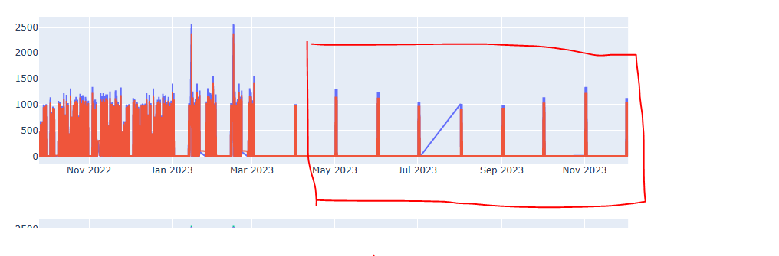

ok

1. I have mentioned in tableau or plotly, I only want to see the graph in 12 hours advanced as stated here. And every next hour the graph will Refresh. It is based on current real time but hourly.

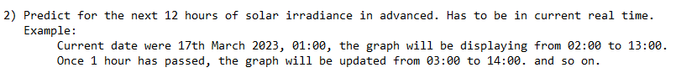

(You told me you could do that with the file I send except up to matlab part)

Ok